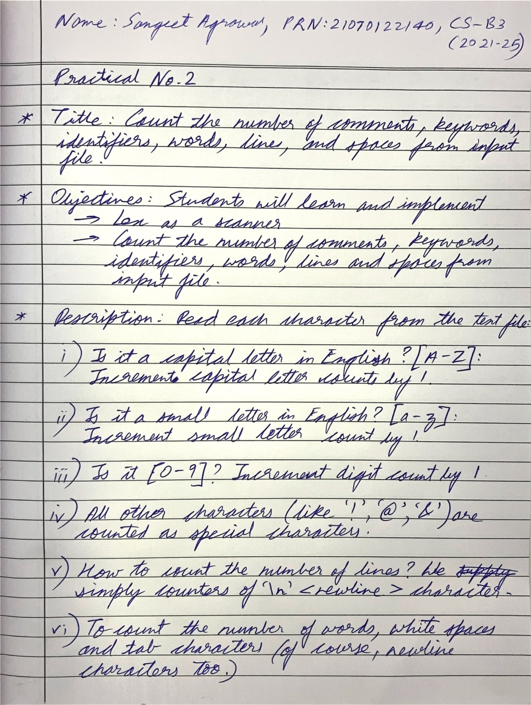

Code:

| %{ #include <stdio.h> #include <ctype.h>  int num_lines = 0; int num_spaces = 0; int num_tabs = 0; int num_words = 0; int num_chars = 0;  char *input_string = "Geeks for Geeks\ngfg gfg\n";  %}  %%  \n { num_lines++; } [ \t]+ {   num_spaces += yyleng;   if (yytext[0] == '\t') num_tabs++;   } [A-Za-z]+ { num_words++; } [0-9]+ { num_chars += yyleng; } . { num_chars++; }  %%  int main() {  printf("Input String:\n%s\n", input_string);   yy_scan_string(input_string);  yylex();   printf("Number of lines: %d\n", num_lines);  printf("Number of spaces: %d\n", num_spaces);  printf("Number of tabs: %d\n", num_tabs);  printf("Number of words: %d\n", num_words);  printf("Number of characters: %d\n", num_chars);   return 0; } |
| --- |

